**International Journal of ITS Research**  
***ITS Japan***  
Nihon Joshikaikan Bldg.



2-6-8, Shibakouen, Minato-ku, Tokyo 105-0011 Japan

TEL: +81-3-5777-1013 / FAX: +81-3-3434-1755  
E-mail: its-journal@its-jp.org



24th September, 2013

Mr. Zhipeng Wang  
Institute of Industrial Science, The University of Tokyo,

**Concerning: International Journal of ITS Research**

Dear Mr. Wang,

We would like to thank you for your participation in submitting the paper to International Journal of ITS Research.

After the peer-review by the Editorial Board, your paper has been accepted for   
**publication subject to minor revision**. You are kindly requested to submit the revised paper at  
<http://www.its-jp.org/journal/www/submission.html> by 23rd October 2013.

Paper ID: 2012-33

Paper title: Detection by Motion-based Grouping of Object Parts

Primary Author: Zhipeng Wang, Institute of Industrial Science, The University of Tokyo,

**Your revised article:**

* Please type corrections/additions in a red font.
* Please explain how the reviewer’s comments were addressed. The explanation should be included at the end of the revised paper.

Thank you again for your interest in the International Journal of ITS Research.

Sincerely yours,

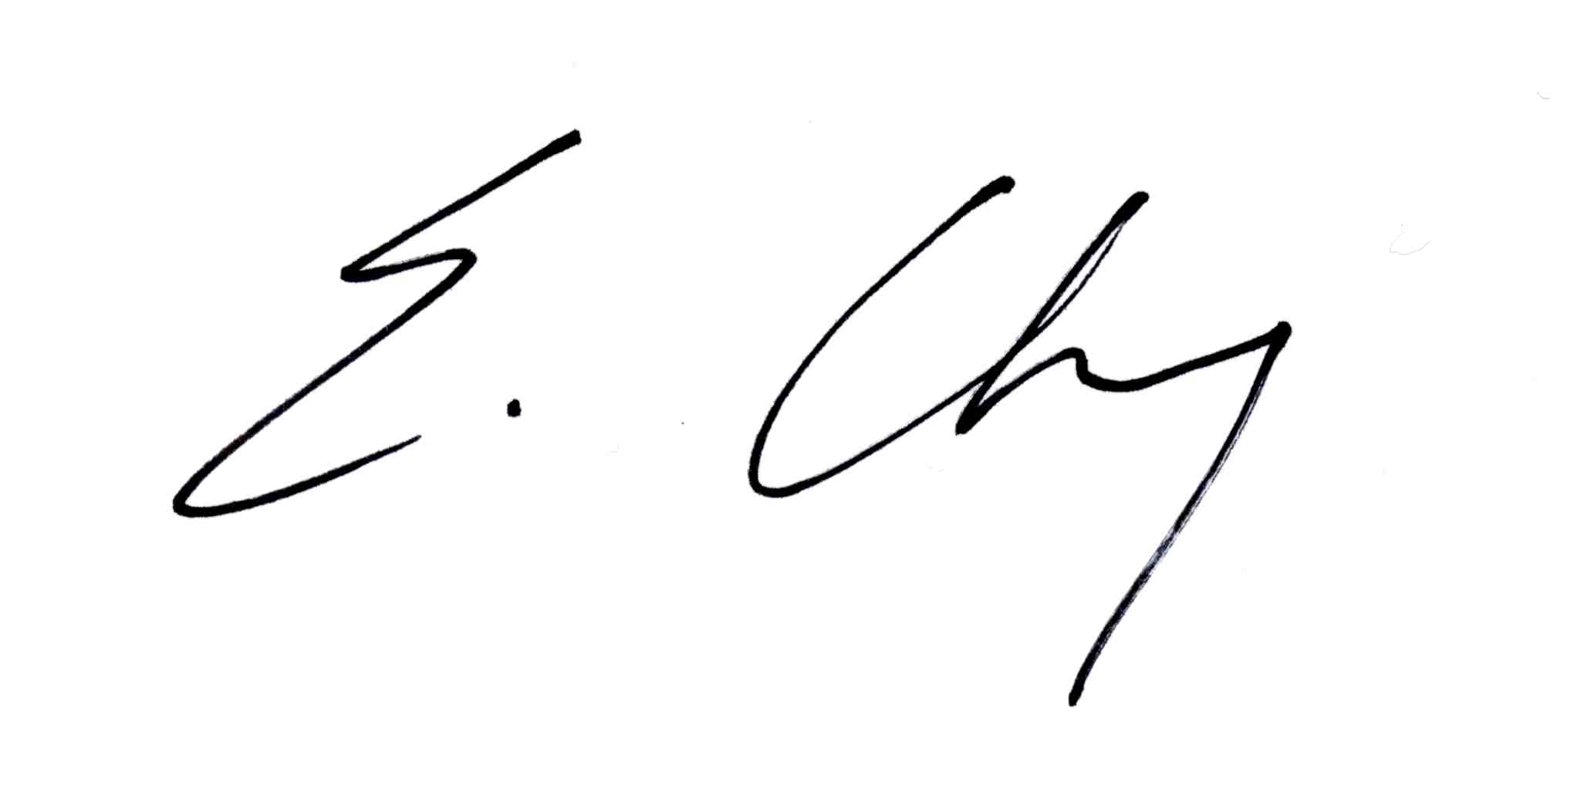

Edward Chung, Ph. D., Queensland University of Technology  
Editor in Chief, International Journal of ITS Research

**1. PAPER DETAILS**

|  |  |  |  |
| --- | --- | --- | --- |
| Paper type | Research Paper | | |
| Paper ID | 2012-33  2005/7/ | | |
| Paper title | Detection by Motion-based Grouping of Object Parts | | |
| Submitted | 8/2/2012 | Re-submitted | 5/16/2013 |

**2. REVIEWER’S RECOMMENDATION**

Please check the box(es) which might indicate the action which should be taken on this paper.

Publish unaltered.

Publish subject to minor revision.

Consider publication after rewrite and review.

Transfer to another journal such as:

Reject

**3. COMMENTS for the author**

The proposed method has the limitation in handling the scale change as described in the response from the authors. Explanations about this limitation should be included in the paper. Also, the proposed method assumes ITS applications using surveillance cameras, which have some restriction on scale change of the pedestrians. The authors should include such discussions.

In section 3.2, both "similarity" and "distance" are used. They are confusing.

"Cross" is inappropriate for describing L. L is the number of frames in which both trajectories exist.

What is "mst" in the last paragraph of section 3.2?

Discussion about max operation for measuring similarity of two trajectories, which is in the response from the authors, should be included in the paper.

In section 5.1, the procedure of training and testing should be clearly described in the paper since the some test images are used for training. And the explanation is necessary why such a procedure is used.

p.1 right bottom: "while" should be removed.